Composite Solids Formed by Addition
# Source: AI Source: Provided by: [Data Path: Persons Table -> ID Column: 1, Name_En Column: Motasem Essam] -> From: [ChatGPT] on [7/25/2026]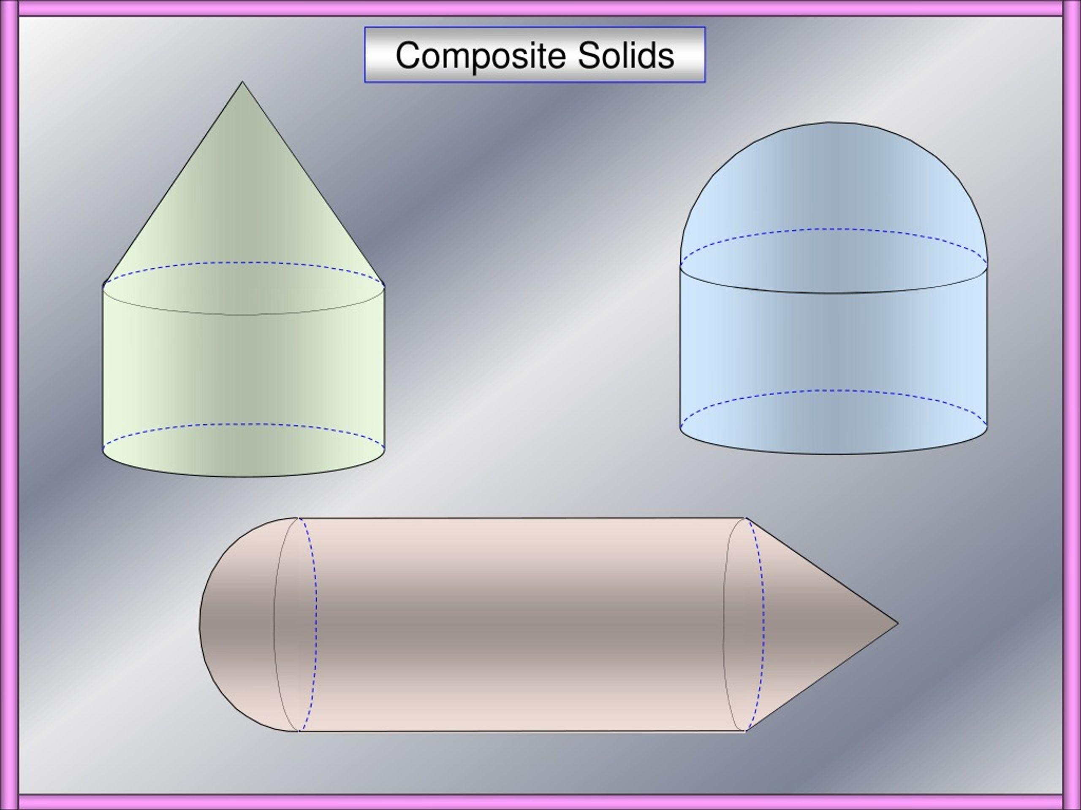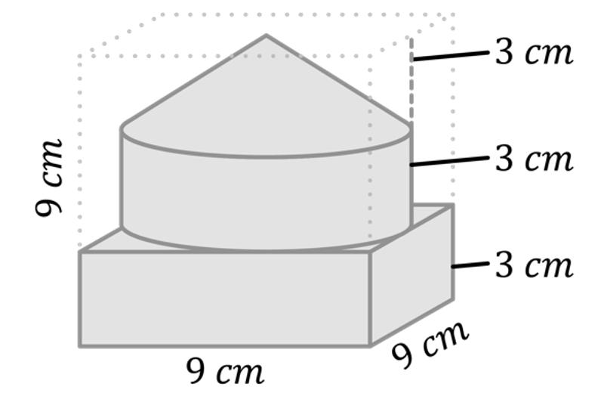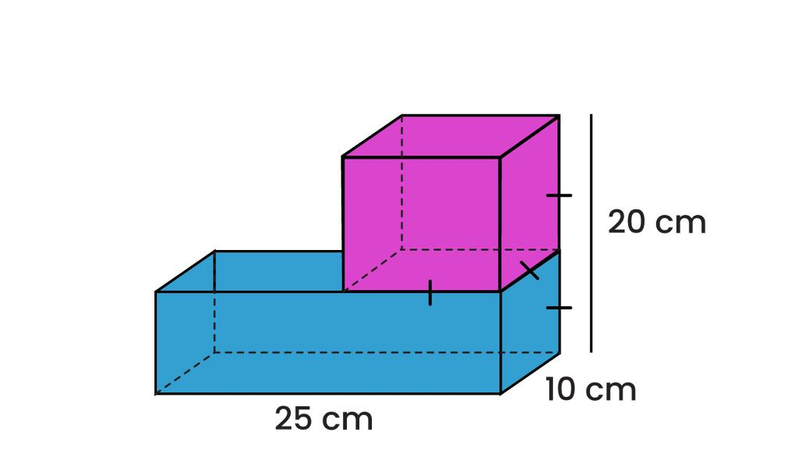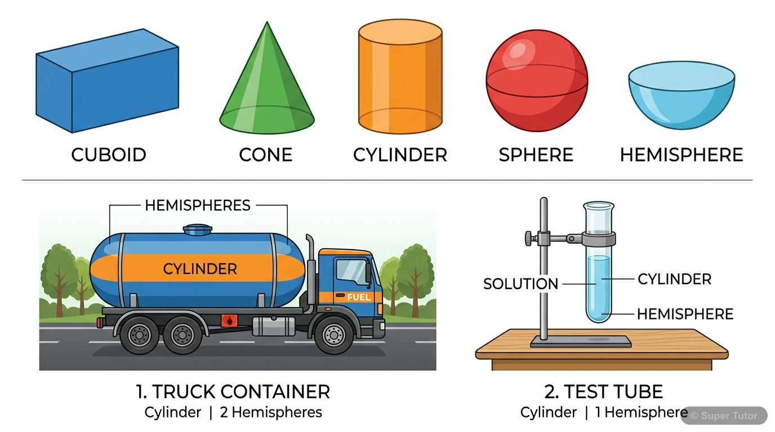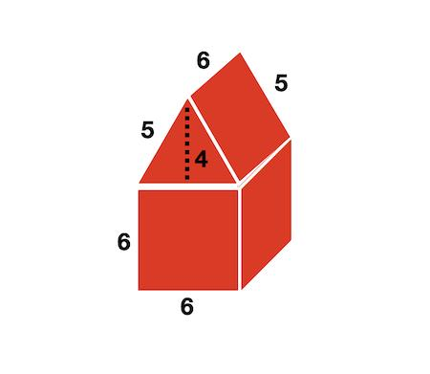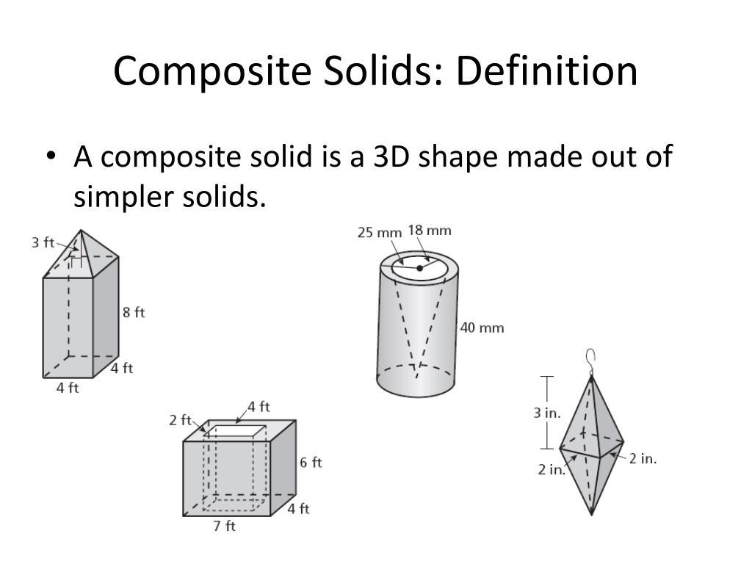

Definition
# Source: AI Source: Provided by: [Data Path: Persons Table -> ID Column: 1, Name_En Column: Motasem Essam] -> From: [ChatGPT] on [7/25/2026]
Composite solids formed by addition are three-dimensional geometric objects created by joining two or more basic geometric solids together to form a single combined solid.
The component solids are combined so that their volumes contribute to the total volume of the resulting object.
This construction is also called additive solid composition or solid addition.
Examples include:
- A cylinder joined to a rectangular prism.
- A cone placed on top of a cylinder.
- A hemisphere attached to a cylinder.
- Multiple prisms joined to form a complex solid.

Simple Definition
# Source: AI Source: Provided by: [Data Path: Persons Table -> ID Column: 1, Name_En Column: Motasem Essam] -> From: [ChatGPT] on [7/25/2026]
A composite solid formed by addition is a 3D shape made by combining two or more smaller solids into one larger shape.
Its total volume is calculated by adding the volumes of its component solids, provided the components do not overlap in volume.

Geometric Representation
# Source: AI Source: Provided by: [Data Path: Persons Table -> ID Column: 1, Name_En Column: Motasem Essam] -> From: [ChatGPT] on [7/25/2026]
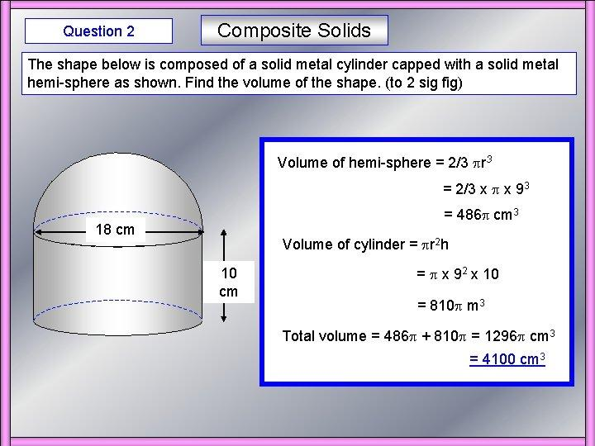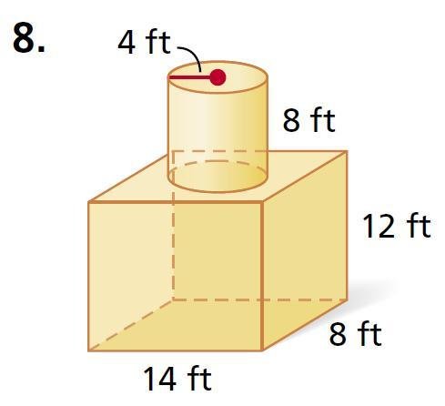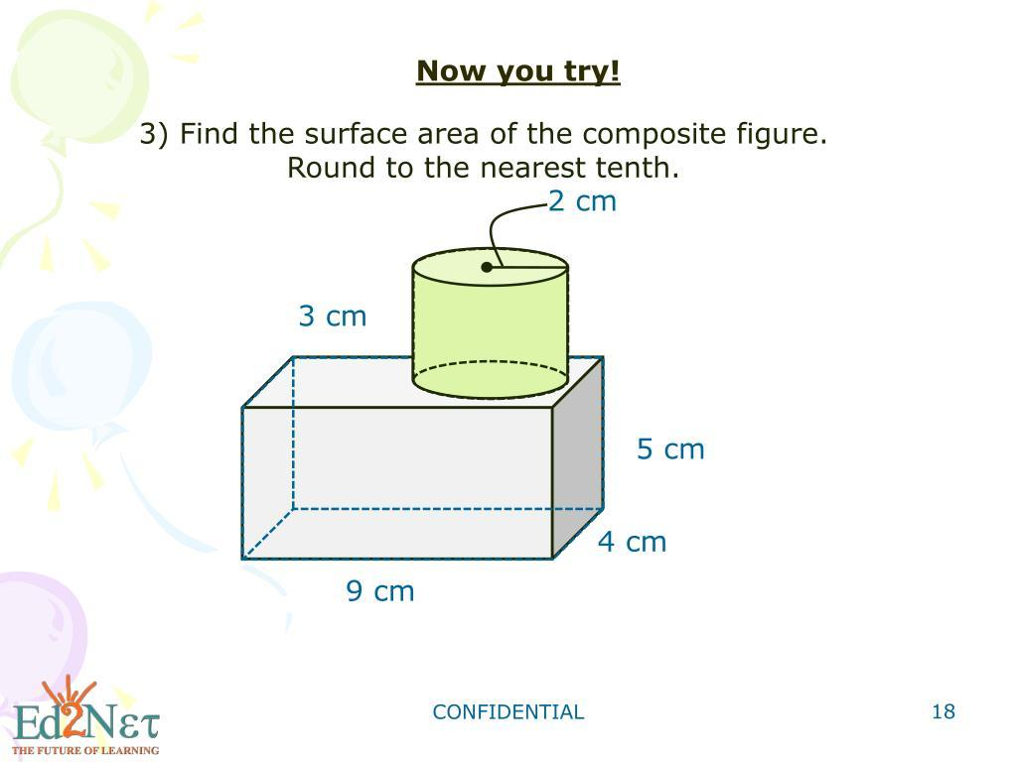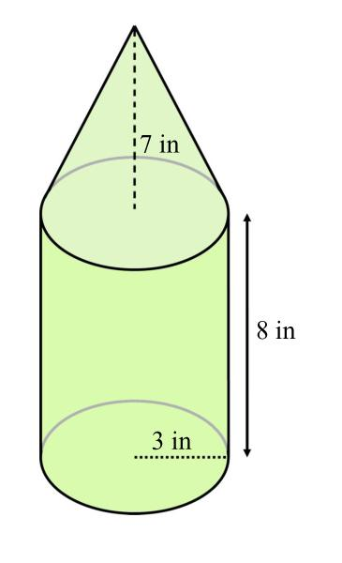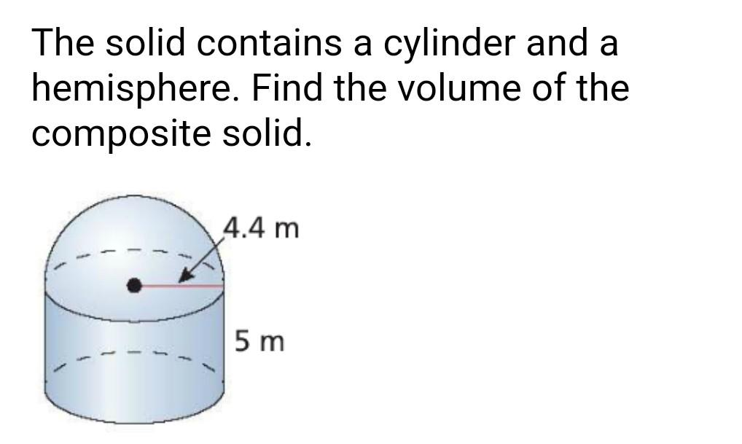
A composite solid formed by addition consists of several geometric components connected together.
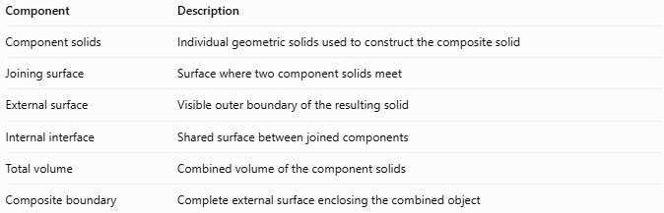
Component | Description
Component solids | Individual geometric solids used to construct the composite solid
Joining surface | Surface where two component solids meet
External surface | Visible outer boundary of the resulting solid
Internal interface | Shared surface between joined components
Total volume | Combined volume of the component solids
Composite boundary | Complete external surface enclosing the combined object

Types of Composite Solids Formed by Addition
# Source: AI Source: Provided by: [Data Path: Persons Table -> ID Column: 1, Name_En Column: Motasem Essam] -> From: [ChatGPT] on [7/25/2026]
Composite solids formed by addition can be classified according to the geometric solids being combined and how they are arranged.

Prism-Based Composite Solids
# Source: AI Source: Provided by: [Data Path: Persons Table -> ID Column: 1, Name_En Column: Motasem Essam] -> From: [ChatGPT] on [7/25/2026]
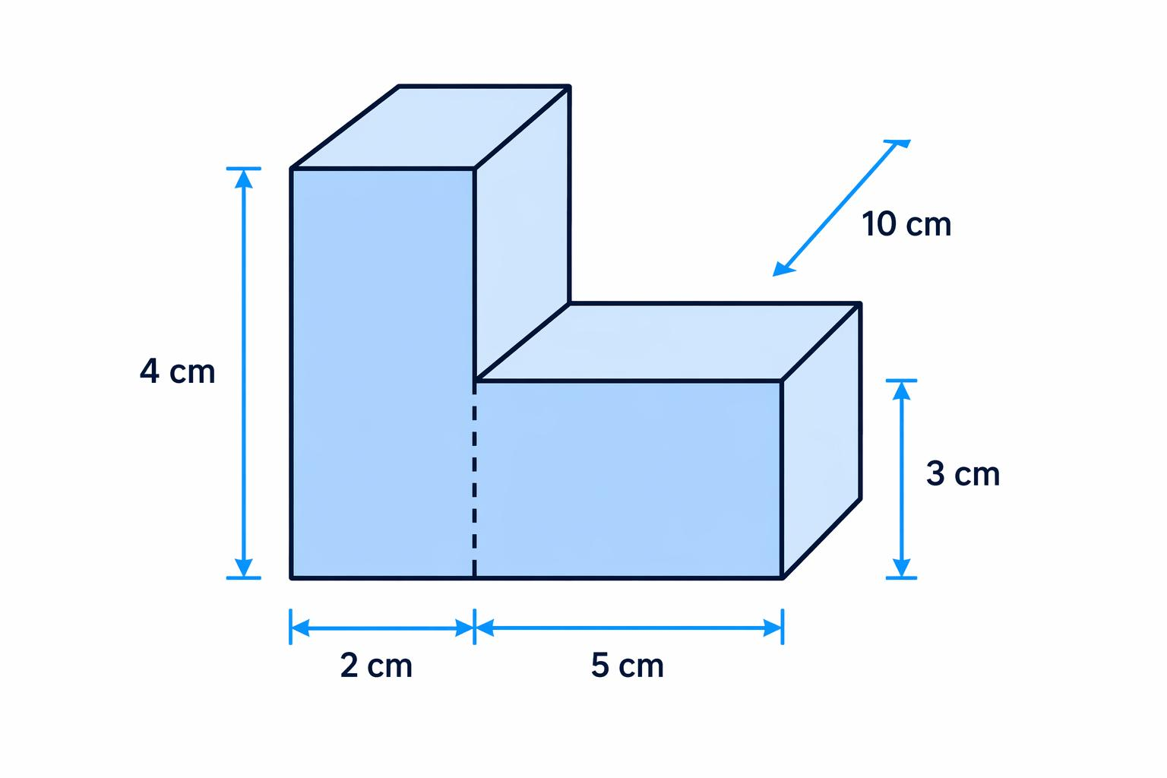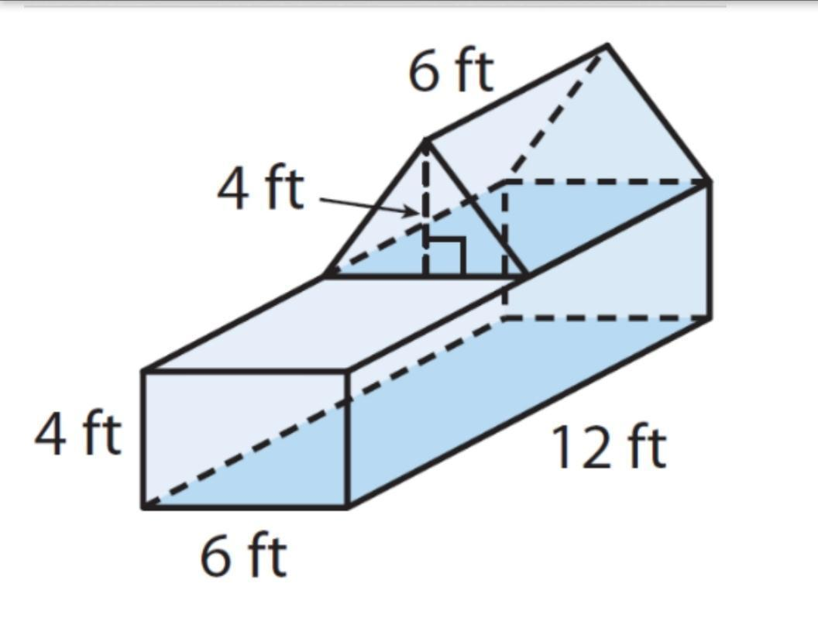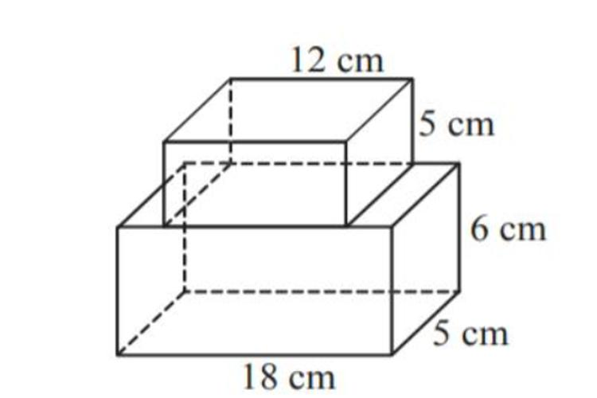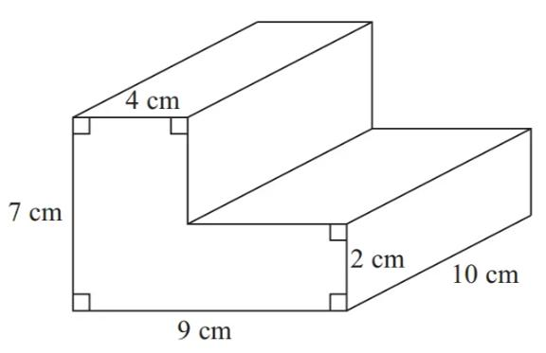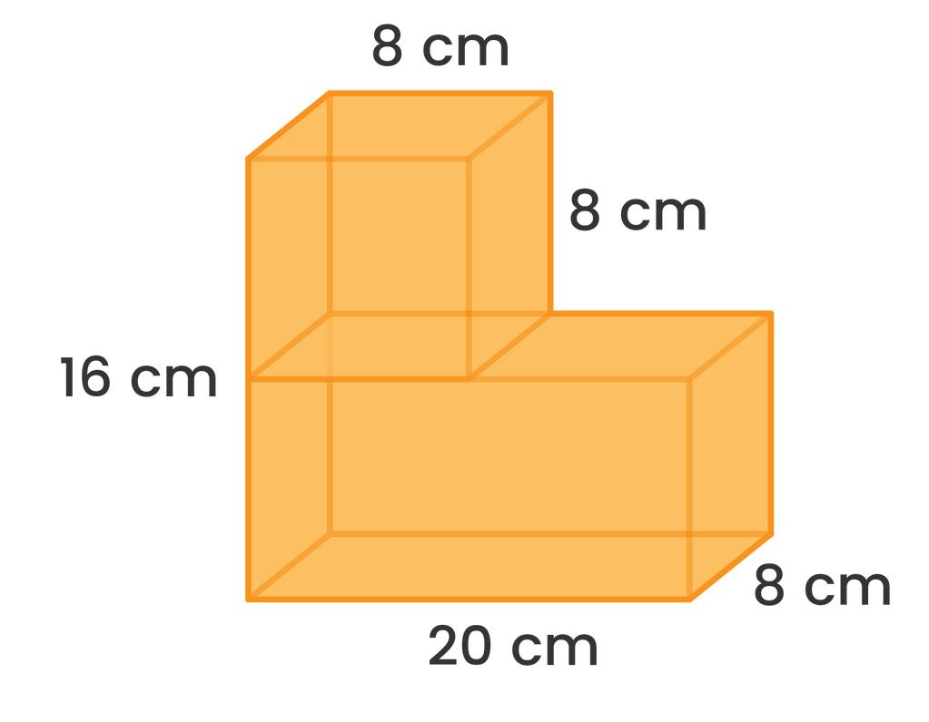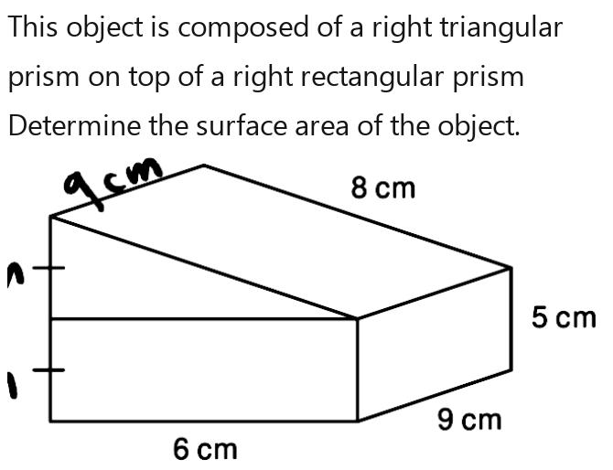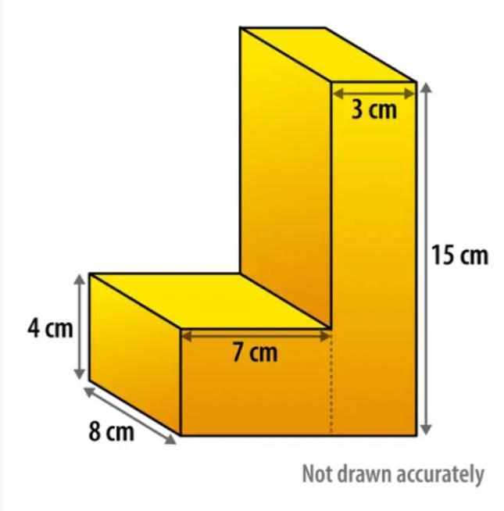
Created by joining two or more prisms.
Examples:
- Rectangular prism joined to rectangular prism.
- Triangular prism joined to rectangular prism.
- Multiple prisms forming an L-shaped solid.
- Multiple prisms forming a stepped solid.

Cylinder-Based Composite Solids
# Source: AI Source: Provided by: [Data Path: Persons Table -> ID Column: 1, Name_En Column: Motasem Essam] -> From: [ChatGPT] on [7/25/2026]
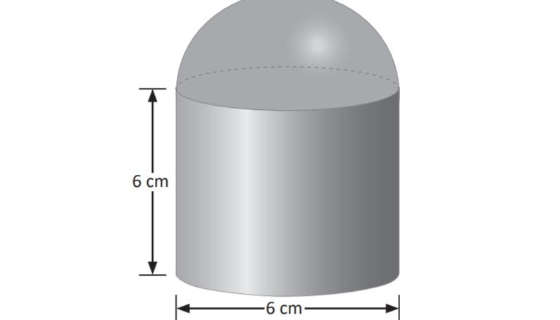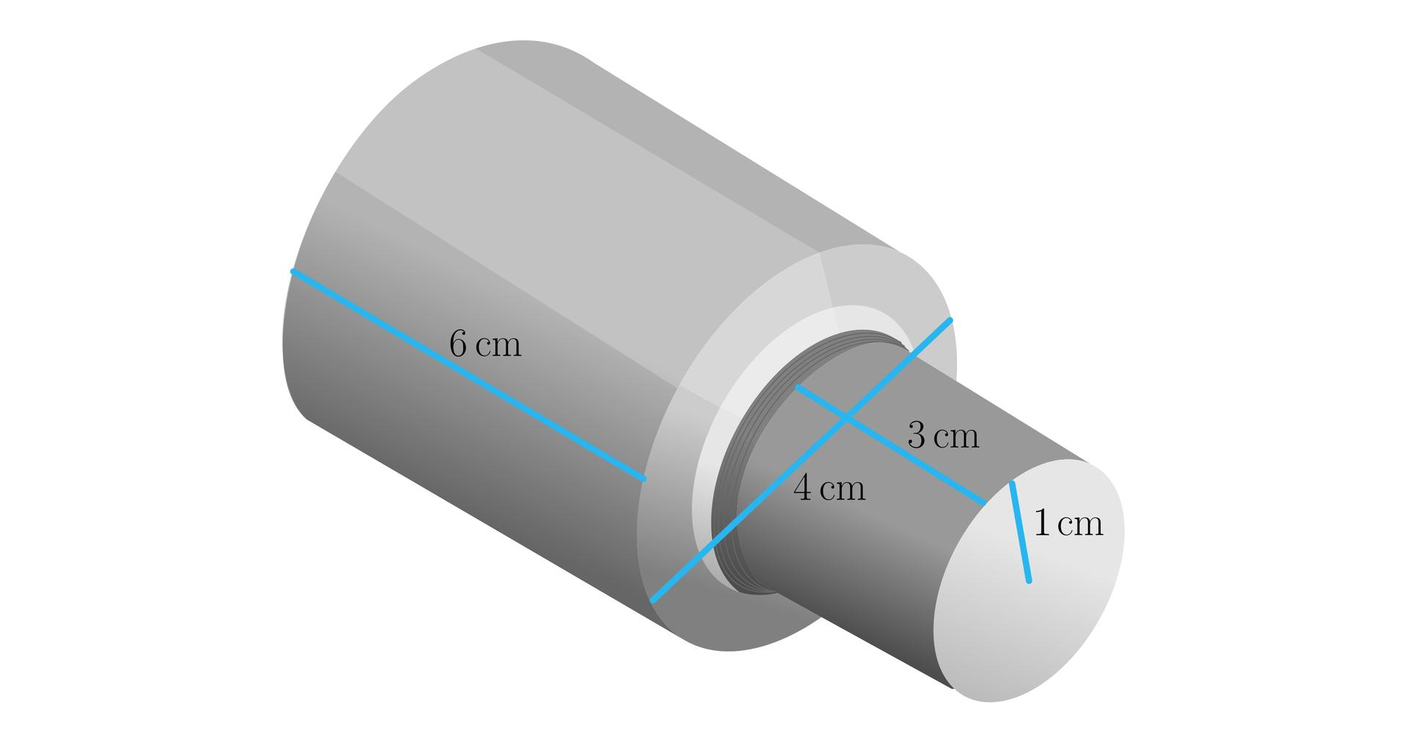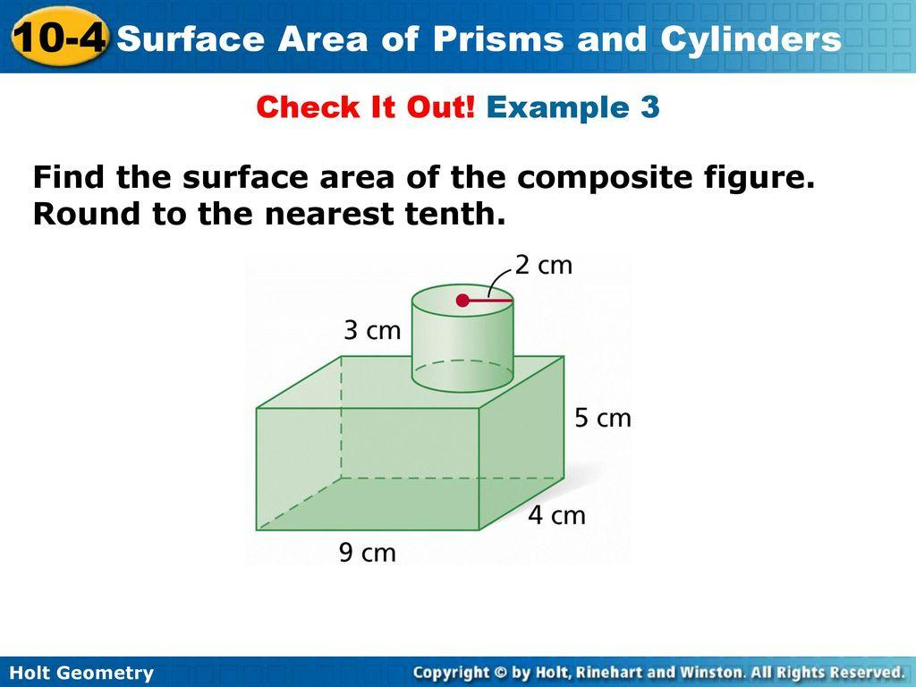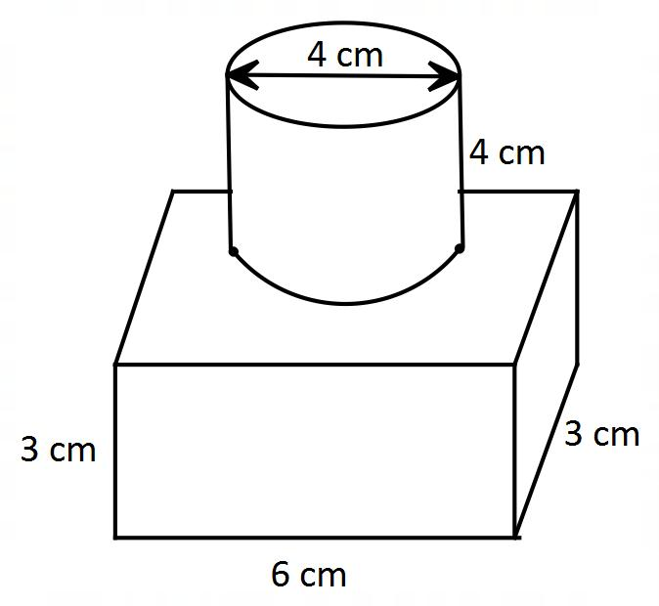
Created by joining cylinders with other cylinders or geometric solids.
Examples:
- Two cylinders joined end to end.
- Cylinder attached to a rectangular prism.
- Cylinder with a hemisphere attached.
- Cylinder combined with a cone.

Cone-Based Composite Solids
# Source: AI Source: Provided by: [Data Path: Persons Table -> ID Column: 1, Name_En Column: Motasem Essam] -> From: [ChatGPT] on [7/25/2026]
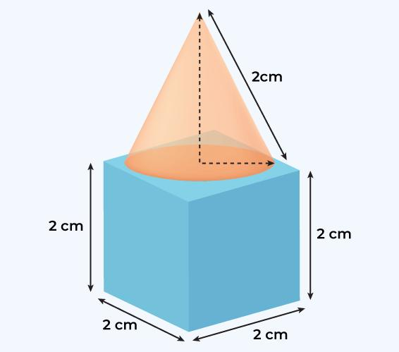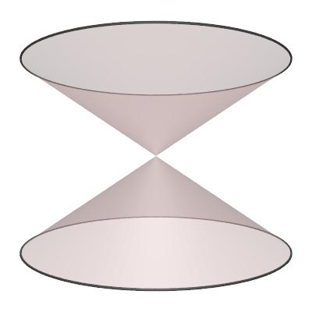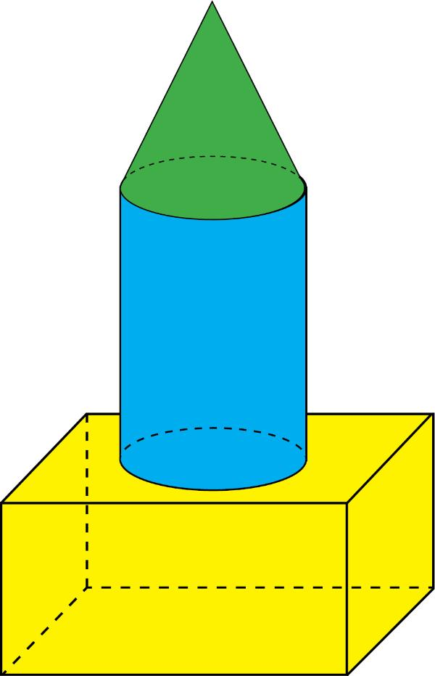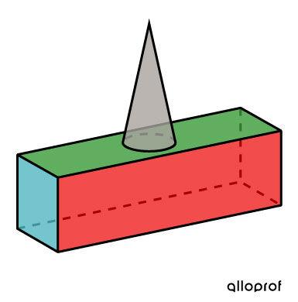
Created by combining one or more cones with other solids.
Examples:
- Cone placed on a cylinder.
- Cone attached to a rectangular prism.
- Two cones joined at their bases.
- Cone combined with a hemisphere.

Pyramid-Based Composite Solids
# Source: AI Source: Provided by: [Data Path: Persons Table -> ID Column: 1, Name_En Column: Motasem Essam] -> From: [ChatGPT] on [7/25/2026]
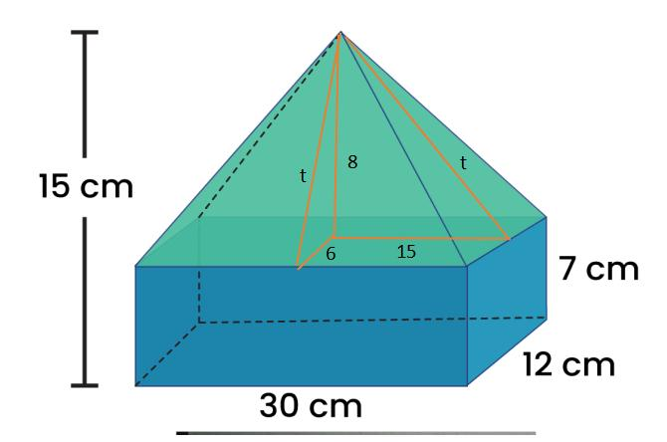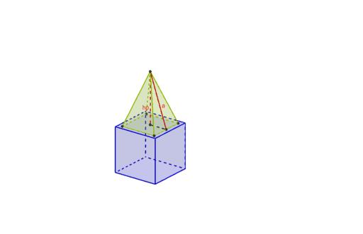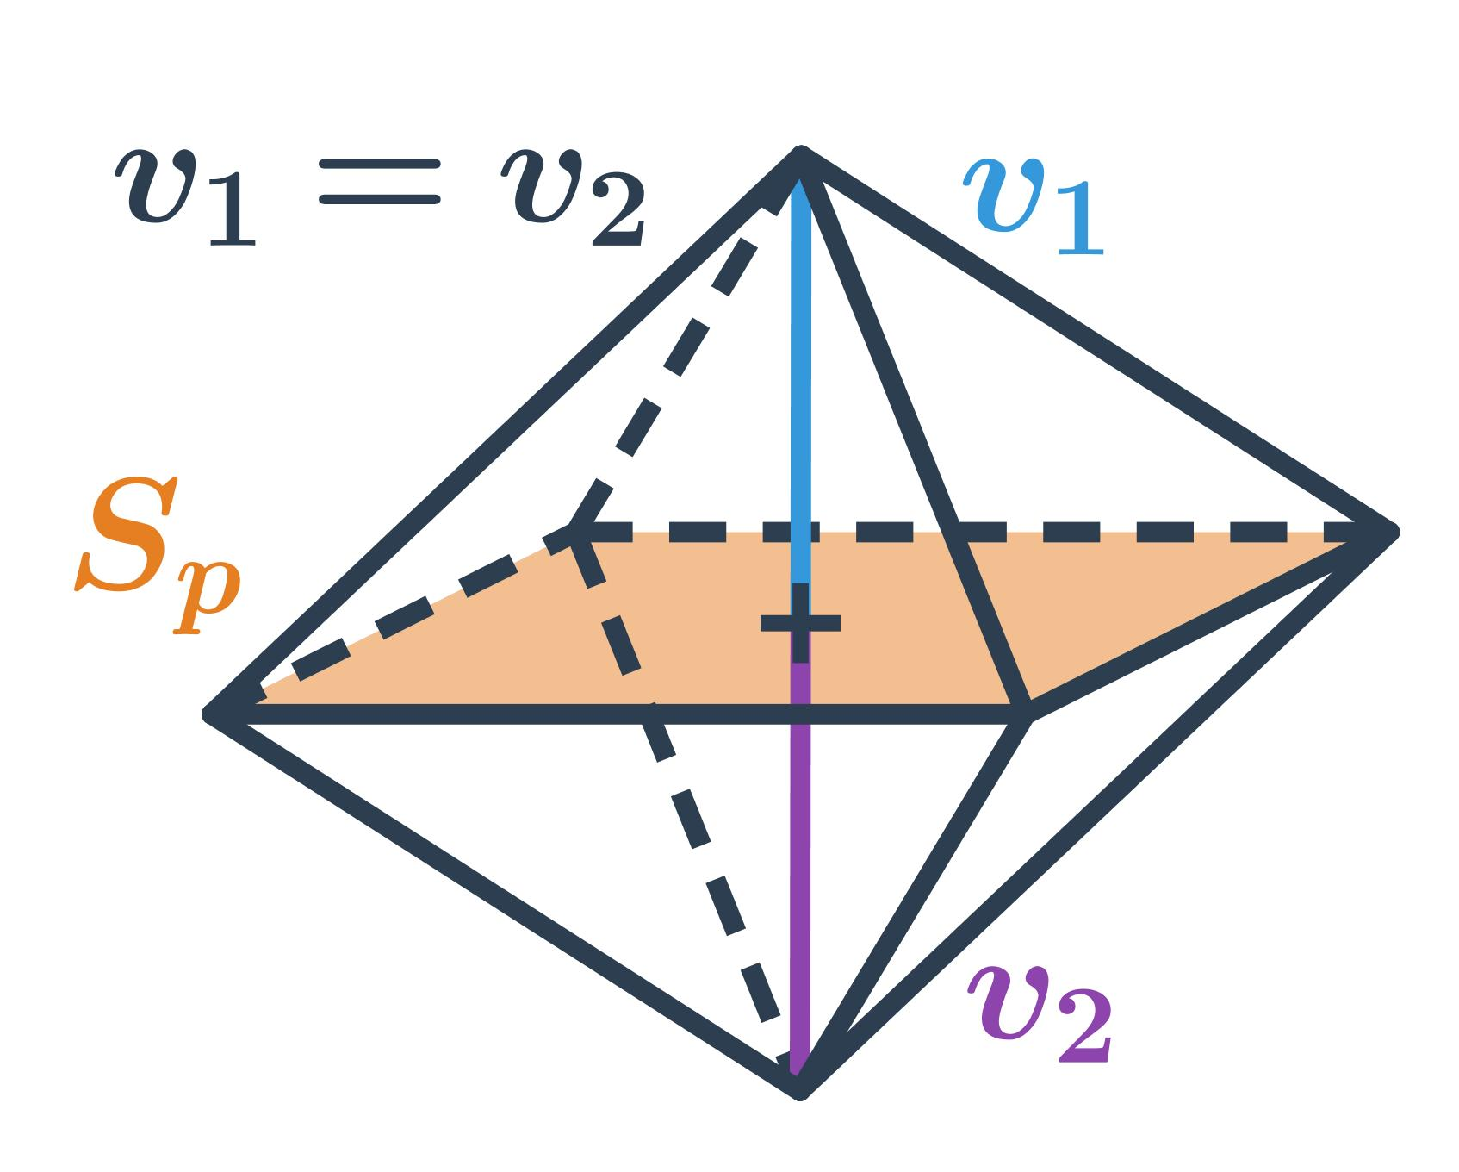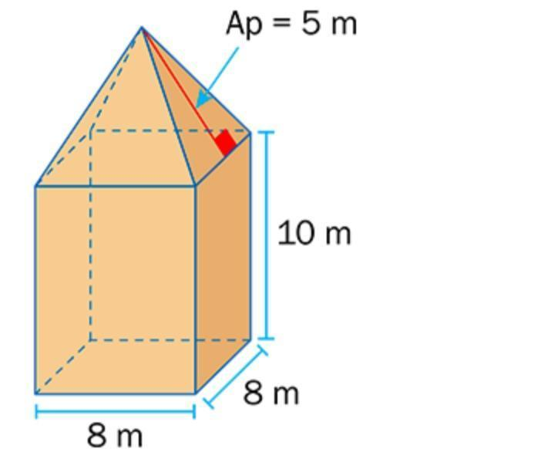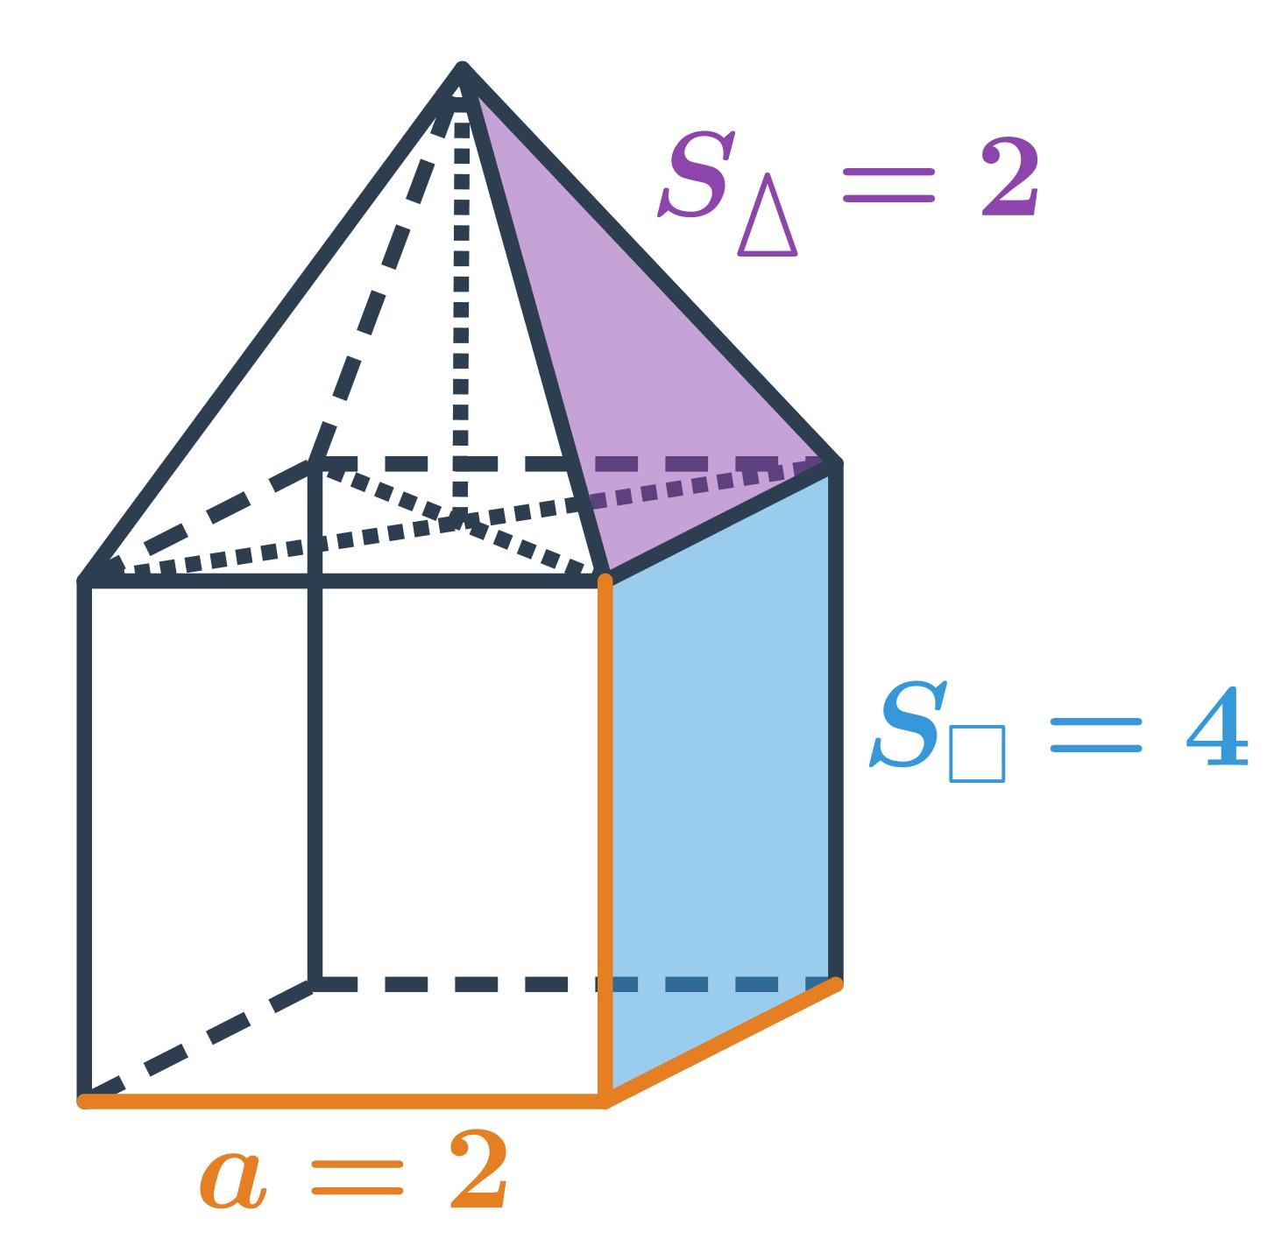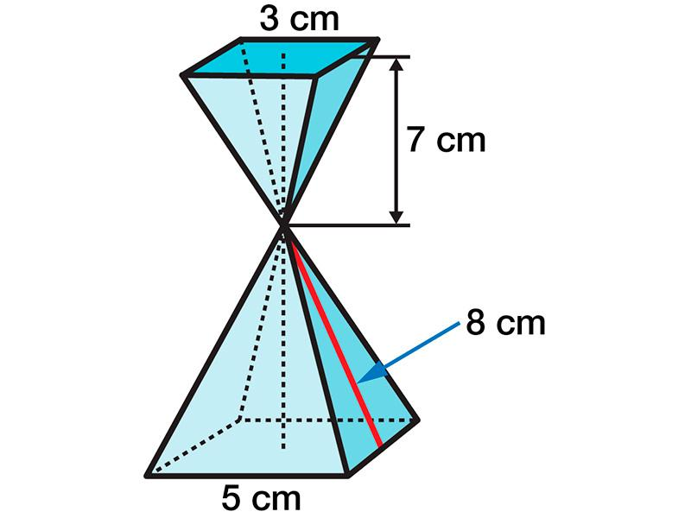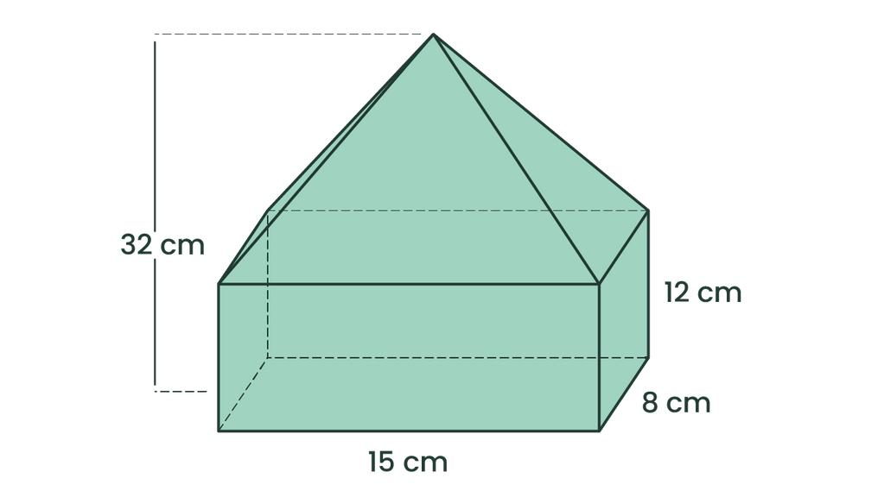
Created by joining pyramids with other solids.
Examples:
- Square pyramid placed on a cube.
- Pyramid attached to a rectangular prism.
- Two pyramids joined at their bases.
- Pyramid combined with a prism.

Sphere-Based Composite Solids
# Source: AI Source: Provided by: [Data Path: Persons Table -> ID Column: 1, Name_En Column: Motasem Essam] -> From: [ChatGPT] on [7/25/2026]
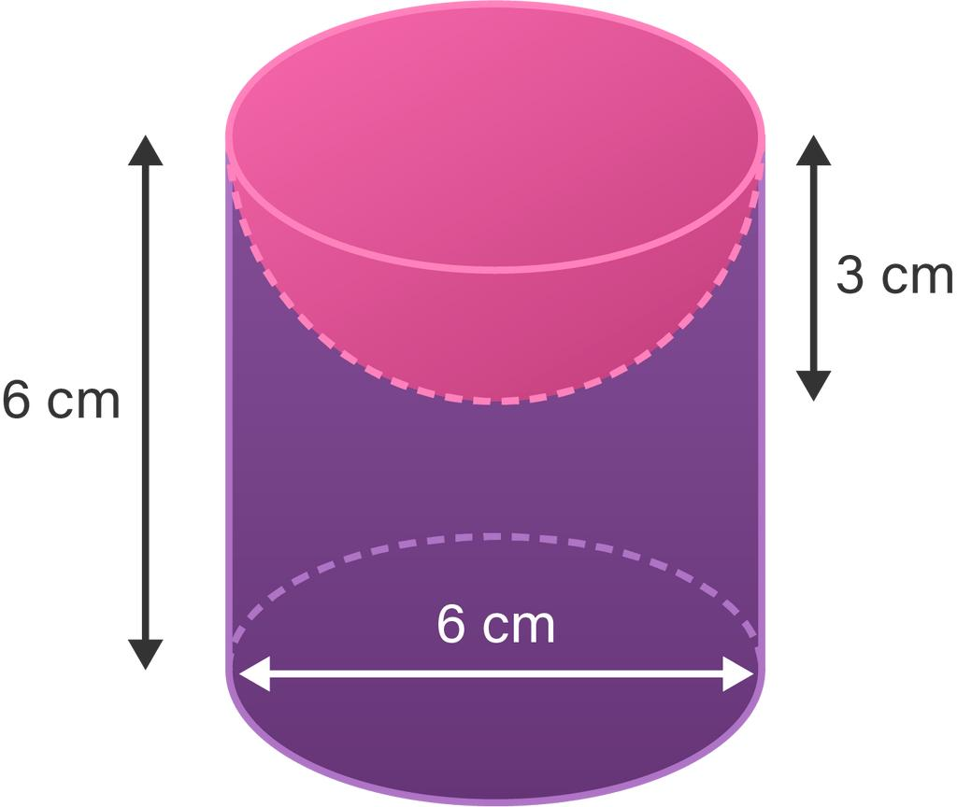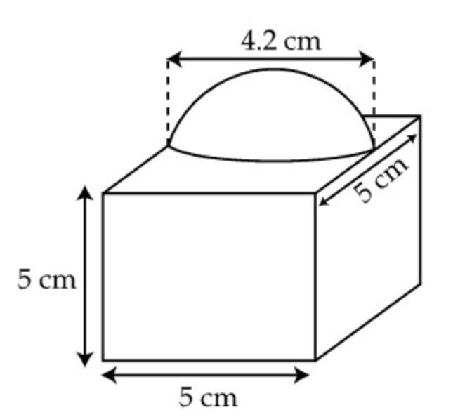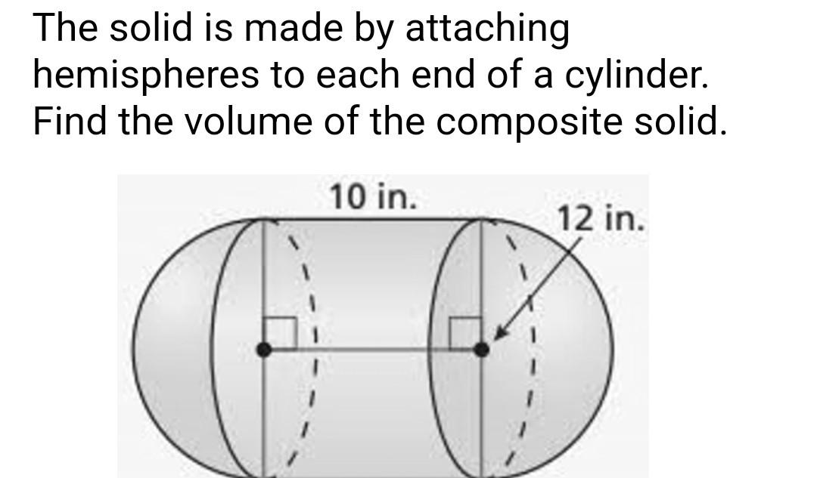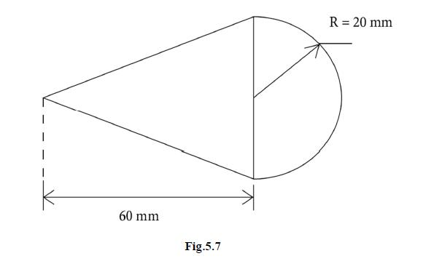
Created by joining spheres or parts of spheres with other solids.
Examples:
- Hemisphere attached to a cylinder.
- Hemisphere placed on a rectangular prism.
- Sphere attached to a cylindrical solid.
- Two hemispheres joined to form a sphere.

Mixed-Shape Composite Solids
# Source: AI Source: Provided by: [Data Path: Persons Table -> ID Column: 1, Name_En Column: Motasem Essam] -> From: [ChatGPT] on [7/25/2026]
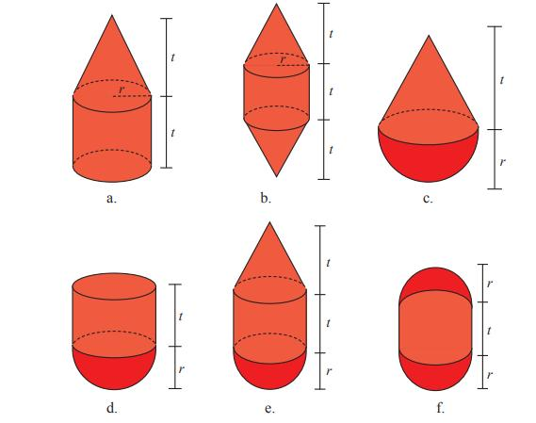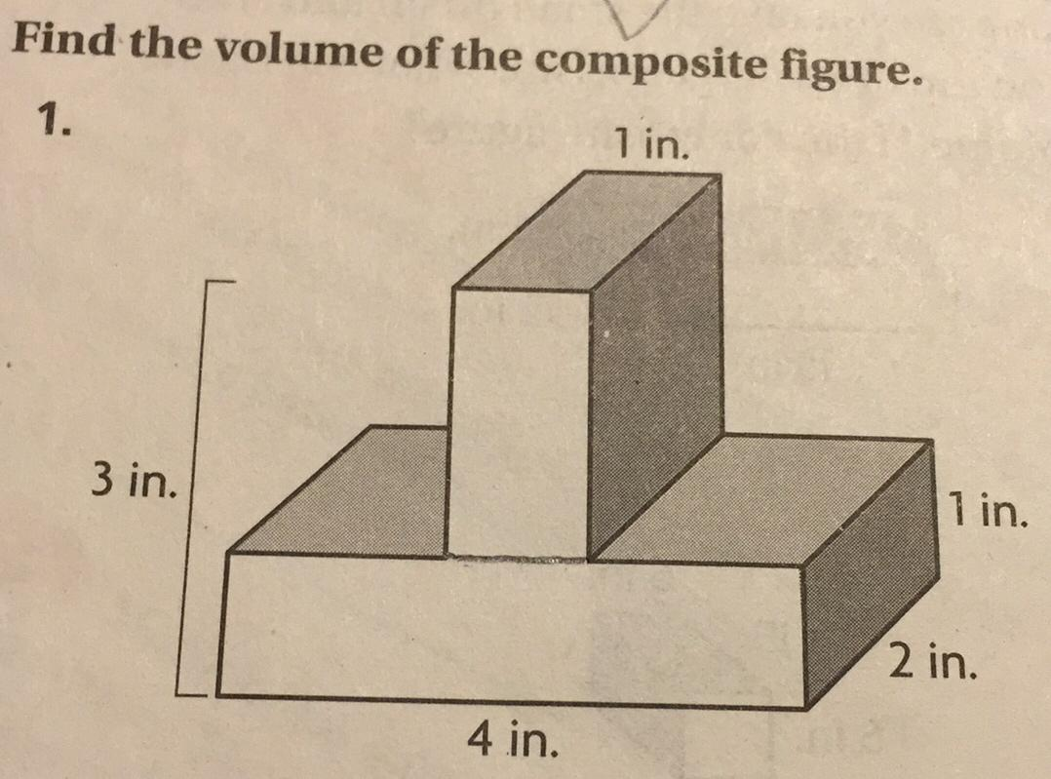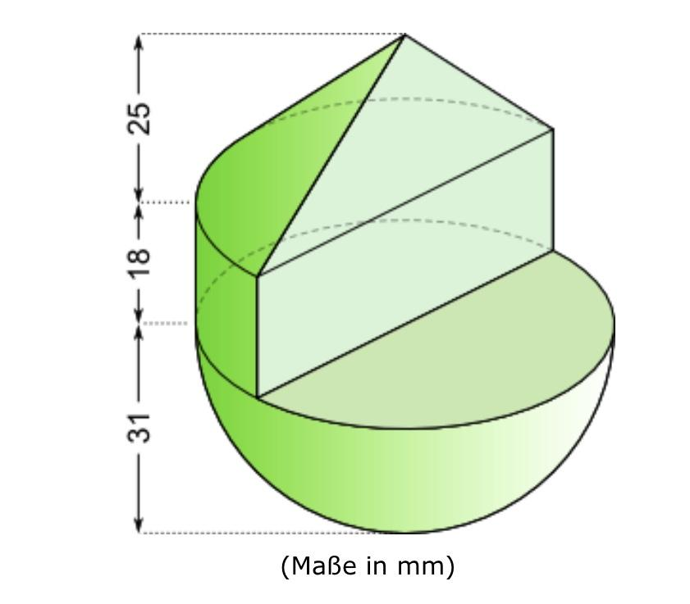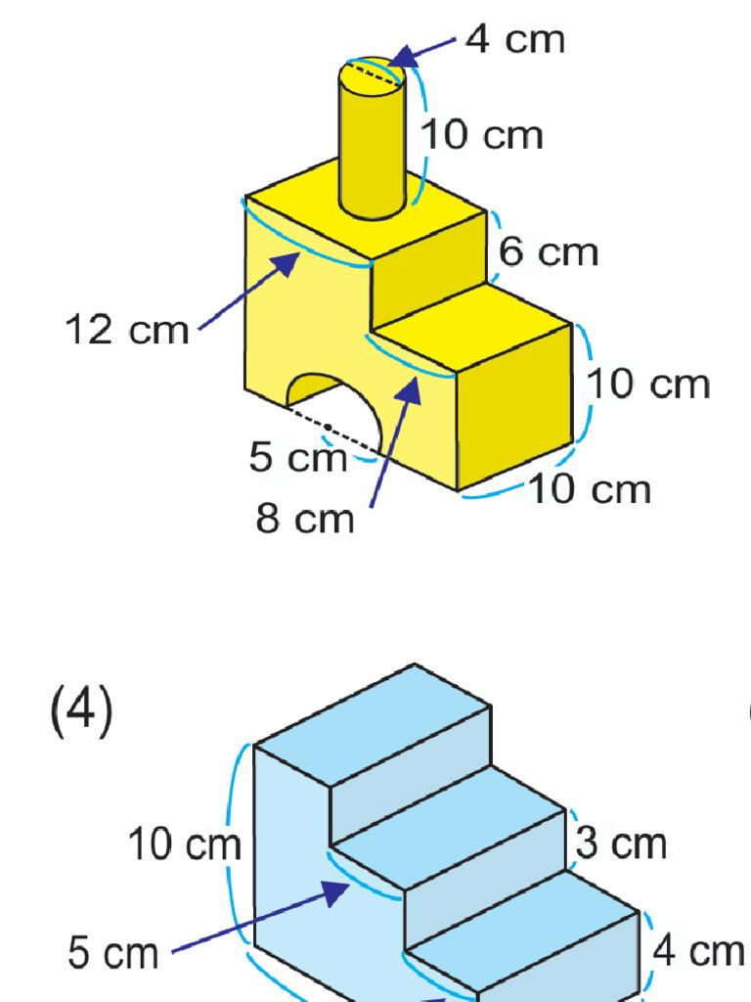
Created by combining different categories of geometric solids.
Examples:
- Rectangular prism + cylinder + hemisphere.
- Cylinder + cone + hemisphere.
- Cube + pyramid + cylinder.
- Prism + cone + sphere.

Classification by Arrangement
# Source: AI Source: Provided by: [Data Path: Persons Table -> ID Column: 1, Name_En Column: Motasem Essam] -> From: [ChatGPT] on [7/25/2026]
Composite solids formed by addition can also be classified according to the arrangement of their component solids.
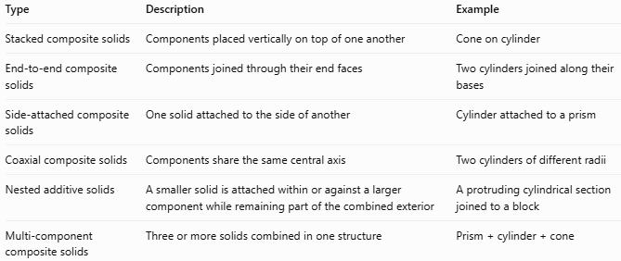
Type | Description | Example
Stacked composite solids | Components placed vertically on top of one another | Cone on cylinder
End-to-end composite solids | Components joined through their end faces | Two cylinders joined along their bases
Side-attached composite solids | One solid attached to the side of another | Cylinder attached to a prism
Coaxial composite solids | Components share the same central axis | Two cylinders of different radii
Nested additive solids | A smaller solid is attached within or against a larger component while remaining part of the combined exterior | A protruding cylindrical section joined to a block
Multi-component composite solids | Three or more solids combined in one structure | $$Prism+cylinder+cone$$
Note: The term "nested" here describes an arrangement of attached components, not one solid completely enclosed inside another.

Mathematical Properties and Formulas

Total Volume
# Source: AI Source: Provided by: [Data Path: Persons Table -> ID Column: 1, Name_En Column: Motasem Essam] -> From: [ChatGPT] on [7/25/2026]
For components that are joined without overlapping in volume:
$$\boxed{V_{total}=V_{1}+V_{2}+⋯+V_{n}}$$
Where:
- $V_{total}$: Total volume of the composite solid.
- $V_{1},V_{2},…,V_{n}$: Volumes of the individual components.

Volume of Common Component Solids
# Source: AI Source: Provided by: [Data Path: Persons Table -> ID Column: 1, Name_En Column: Motasem Essam] -> From: [ChatGPT] on [7/25/2026]
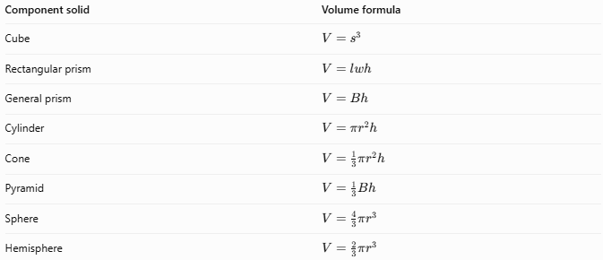
Component solid | Volume formula
Cube | $$V=s^{3}$$
Rectangular prism | $$V=lwh$$
General prism | $$V=Bh$$
Cylinder | $$V=πr^{2}h$$
Cone | $$V=\frac{1}{3}πr^{2}h$$
Pyramid | $$V=\frac{1}{3}Bh$$
Sphere | $$V=\frac{4}{3}πr^{3}$$
Hemisphere | $$V=\frac{2}{3}πr^{3}$$
Here, $B$ represents the area of the base.

External Surface Area
# Source: AI Source: Provided by: [Data Path: Persons Table -> ID Column: 1, Name_En Column: Motasem Essam] -> From: [ChatGPT] on [7/25/2026]
The external surface area is not always the simple sum of the surface areas of the component solids.
When two components are joined along a shared interface, that interface becomes internal and is not included in the external surface area.
For two solids joined along a shared surface:
$$\boxed{S_{external}=S_{1}+S_{2}-2A_{shared}}$$
Where:
- $S_{1},S_{2}$: Surface areas of the individual solids.
- $A_{shared}$: Area of the shared joining surface.
For more complicated arrangements, all internal interfaces must be excluded, and overlapping external surfaces must be handled carefully.

Worked Examples

Example 1: Cylinder Joined to a Hemisphere
# Source: AI Source: Provided by: [Data Path: Persons Table -> ID Column: 1, Name_En Column: Motasem Essam] -> From: [ChatGPT] on [7/25/2026]
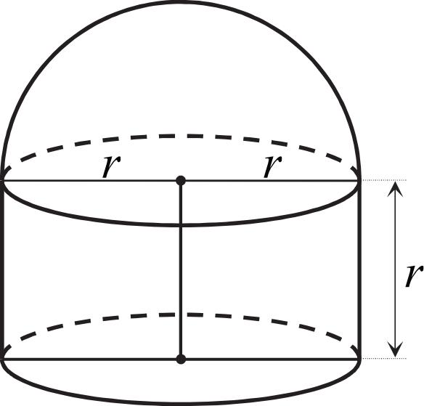
A hemisphere is attached to the top of a cylinder.
Given:
- Radius: $r=3$ cm
- Cylinder height: $h=8$ cm
Step 1: Calculate the cylinder volume
$$V_{1}=πr^{2}h$$
$$V_{1}=π(3)^{2}(8)=72π$$
Step 2: Calculate the hemisphere volume
$$V_{2}=\frac{2}{3}πr^{3}$$
$$V_{2}=\frac{2}{3}π(3)^{3}=18π$$
Step 3: Calculate the total volume
$$V_{total}=72π+18π$$
$$\boxed{V_{total}=90π≈282.74{ cm}^{3}}$$

Example 2: Cone Joined to a Cylinder
# Source: AI Source: Provided by: [Data Path: Persons Table -> ID Column: 1, Name_En Column: Motasem Essam] -> From: [ChatGPT] on [7/25/2026]
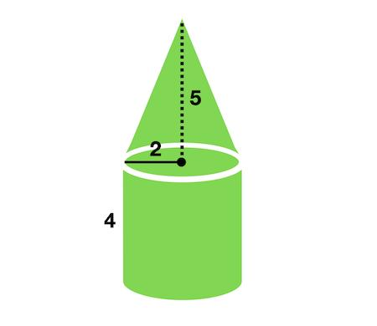
A cone is placed on top of a cylinder. Both have the same base radius.
Given:
- Radius: $r=4$ cm
- Cylinder height: $h_{1}=6$ cm
- Cone height: $h_{2}=3$ cm
Step 1: Calculate the cylinder volume
$$V_{1}=πr^{2}h_{1}$$
$$V_{1}=π(4)^{2}(6)=96π$$
Step 2: Calculate the cone volume
$$V_{2}=\frac{1}{3}πr^{2}h_{2}$$
$$V_{2}=\frac{1}{3}π(4)^{2}(3)=16π$$
Step 3: Calculate the total volume
$$V_{total}=96π+16π$$
$$\boxed{V_{total}=112π≈351.86{ cm}^{3}}$$

Important Characteristics
# Source: AI Source: Provided by: [Data Path: Persons Table -> ID Column: 1, Name_En Column: Motasem Essam] -> From: [ChatGPT] on [7/25/2026]
- Consist of two or more basic geometric solids.
- Form one combined three-dimensional object.
- Components are connected through joining surfaces or interfaces.
- The total volume is the sum of component volumes when there is no overlap.
- Internal joining surfaces are excluded from the external surface area.
- Components may be identical or geometrically different.
- Components may be arranged vertically, horizontally, coaxially, or side by side.
- The resulting solid may have a more complex external boundary than any individual component.

Comparison with Other Types of Composite Solids
# Source: AI Source: Provided by: [Data Path: Persons Table -> ID Column: 1, Name_En Column: Motasem Essam] -> From: [ChatGPT] on [7/25/2026]
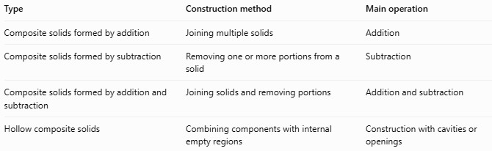
Type | Construction method | Main operation
Composite solids formed by addition | Joining multiple solids | Addition
Composite solids formed by subtraction | Removing one or more portions from a solid | Subtraction
Composite solids formed by addition and subtraction | Joining solids and removing portions | Addition and subtraction
Hollow composite solids | Combining components with internal empty regions | Construction with cavities or openings

Applications
# Source: AI Source: Provided by: [Data Path: Persons Table -> ID Column: 1, Name_En Column: Motasem Essam] -> From: [ChatGPT] on [7/25/2026]
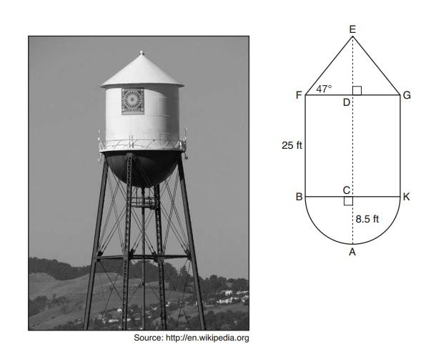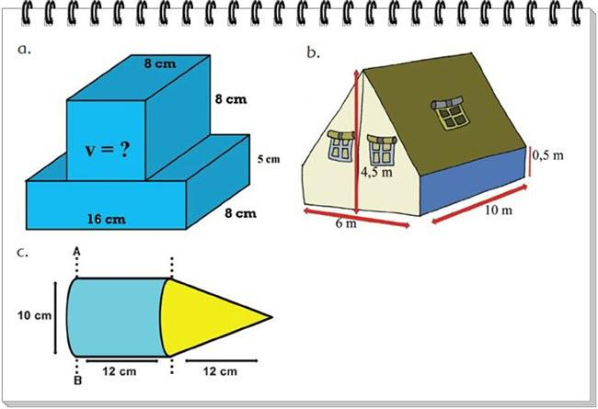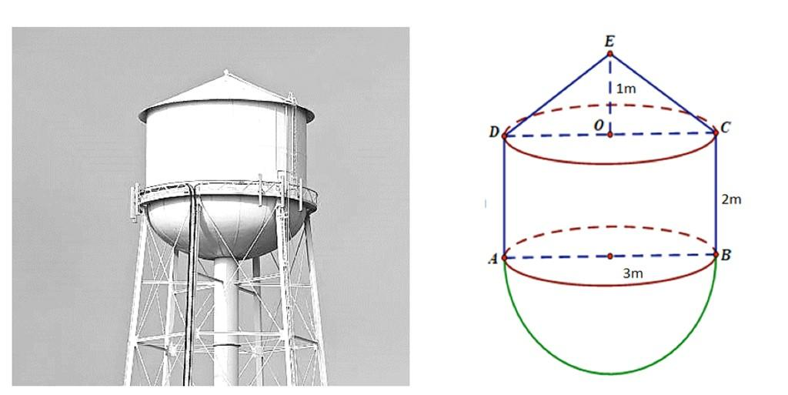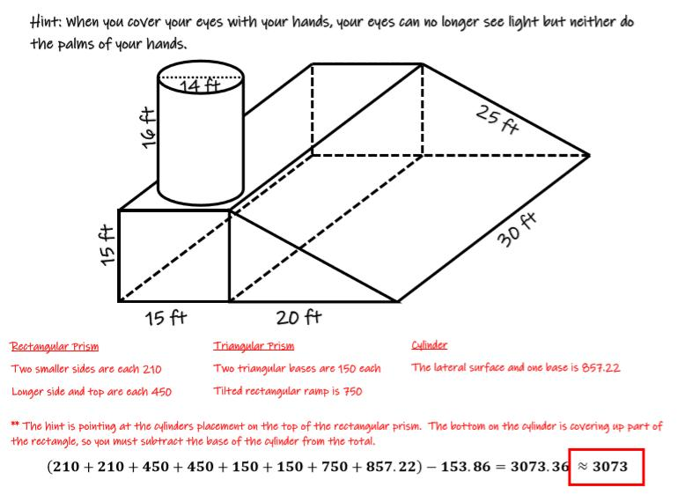
- Architecture: Buildings, towers, domes, and structures made from combined geometric forms.
- Engineering: Mechanical components assembled from cylindrical, prismatic, and other shapes.
- Manufacturing: Products formed by joining multiple solid components.
- Construction: Tanks, columns, roofs, and structural elements.
- Mathematics education: Calculating the volume and external surface area of complex objects.

Key Points
# Source: AI Source: Provided by: [Data Path: Persons Table -> ID Column: 1, Name_En Column: Motasem Essam] -> From: [ChatGPT] on [7/25/2026]
- Composite solids formed by addition combine two or more geometric solids.
- Their components form one connected object.
- The total volume is the sum of component volumes when the components do not overlap.
- Shared joining surfaces are internal and must not be counted in external surface-area calculations.
- They can contain identical solids or different types of solids.
- They can be classified by component shape and arrangement.

Conclusion
# Source: AI Source: Provided by: [Data Path: Persons Table -> ID Column: 1, Name_En Column: Motasem Essam] -> From: [ChatGPT] on [7/25/2026]
Composite solids formed by addition are three-dimensional objects constructed by joining two or more basic geometric solids. They can contain prisms, cylinders, cones, pyramids, spheres, and other solid shapes. Their volume is calculated by adding the component volumes when there is no overlap, while their external surface area requires excluding internal joining surfaces.

